PRICING: Case Study Name: ____________________
© Stephan Sorger 2020; www.stephansorger.com Date: ____________________

Chapter | Case Study
2 | Price and Economics: Organic Produce

Background:
You are the pricing manager for Acme Organic, a producer of organic fruit and vegetables. One of your most popular items is organic tomatoes. The produce is sold through supermarket chain SuperShop. SuperShop has two stores that are steady customers of your produce. The first store is SuperShopHi, which is located in an area of high income earners. The second store is SuperShopLo, which is located in an area of low income earners.

The price of the organic tomatoes changes over time, due to changes in supply and demand. You wish to understand how demand for your tomatoes changes with price, and the difference (if any) between sales of SuperShopHi and SuperShopLo.

The case is based on various studies:
1. Durham, Catherine and Eales, James. “Demand elasticities for fresh fruit at the retail level.” Journal of Applied Economics. Volume 42, 2010; Issue 11.
2. Jones, Eugene and Mustiful, Barry. “Purchasing behavior of higher and lower income shoppers: a look at breakfast cereals.” Journal of Applied Economics. Volume 28, 1996; Issue 01.
3. Xlstat.com. “Price elasticity of demand (PED) tutorial in Excel. help.xlstat.com. February 05, 2019.

The price and corresponding quantity for tomatoes at SuperShopHi is shown in the following table:

Price | Quantity
2.49 | 220
2.59 | 219
2.69 | 215
2.79 | 212
2.89 | 208
2.99 | 207
3.09 | 205
3.19 | 205
3.29 | 204
3.39 | 202
3.49 | 198
3.59 | 197
3.69 | 194
3.79 | 194
3.89 | 193
3.99 | 193

The price and corresponding quantity for tomatoes at SuperShopLo is shown in the following table:

Price | Quantity
2.49 | 110
2.59 | 108
2.69 | 103
2.79 | 101
2.89 | 95
2.99 | 91
3.09 | 90
3.19 | 86
3.29 | 80
3.39 | 75
3.49 | 71
3.59 | 66
3.69 | 64
3.79 | 59
3.89 | 55
3.99 | 54

Instructions

1. Plot out the demand curve for Acme Organic tomatoes at SuperShopHi. Hint: In Microsoft Excel, select the data, then select Insert from the top menu, then select Scatter, then select the variant of Scatter called, “Scatter with smooth lines and markers” (or equivalent). Plot the demand curve with Price on the vertical axis and Quantity on the horizontal axis. Take a screenshot of the plot and insert it below.

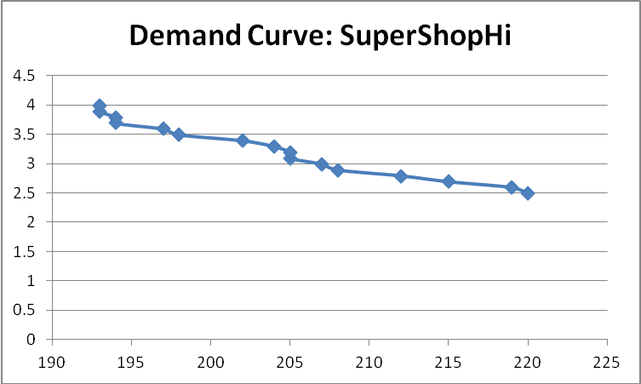

2. Plot out the demand curve for Acme Organic tomatoes at SuperShopLo. Take a screenshot of the plot and insert it below.

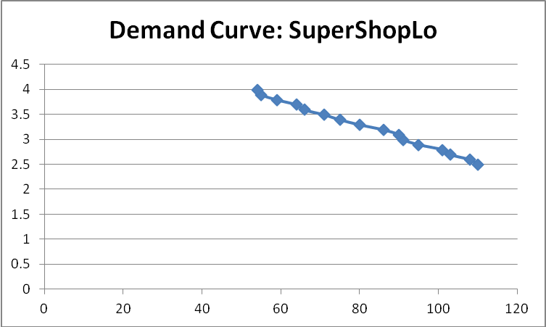

3. Calculate the percentage change in Q (Quantity) for SuperShopHi as price changes. The equation for percentage is:
(Q2 – Q1) / Q1,
where Q1 is the quantity associated with one particular price, such as the first price in the series, and Q2 is the quantity associated with the next price in the series. Do the calculations for all of the quantities in the series for SuperShopHi and place the results in a column to the right of the Quantity and Price data. Take a screenshot of the columns Quantity, Price, and Percentage Change in Q and insert it below.

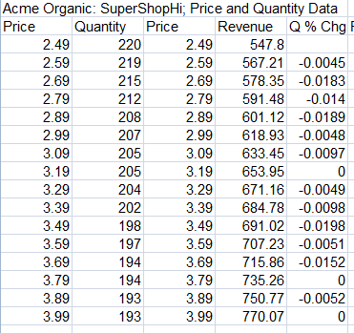

4. Calculate the percentage change in P (Price) for SuperShopHi as price changes. The equation for percentage is:
(P2 – P1) / P1,
where P1 is the earlier price in the series, such as the first price in the series, and P2 is the next price in the series, such as the second price in the series. Do the calculations for all of the prices in the series for SuperShopHi and place the results in a column to the right of the Percentage Change in Q column. Take a screenshot of the columns Quantity, Price, Percentage Change in Q, and Percentage Change in P, and insert it below.

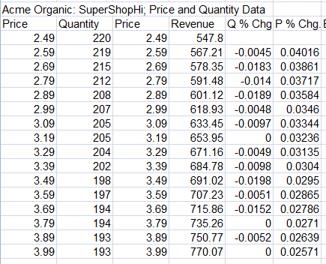

5. Calculate the elasticity for the data associated with SuperShopHi. The equation for elasticity is:
(Percentage change in Q) / (Percentage change in P)
Now that the percentage changes in Q and percentage changes in P have been calculated, it is a simple matter of dividing the value in the (Percentage change in Q) column by the corresponding value in the (Percentage change in P) column. Do this for all values in the series. Add a column to the right of the elasticity values you just calculated. In that new column, enter the absolute values of the elasticities you just calculated. Take a screenshot of the columns Quantity, Price, Percentage Change in Q, Percentage Change in P, and Elasticity, and insert it below.

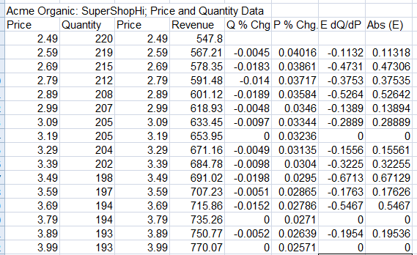

6. Average the values in the Elasticity for SuperShopHi and place the answer below.

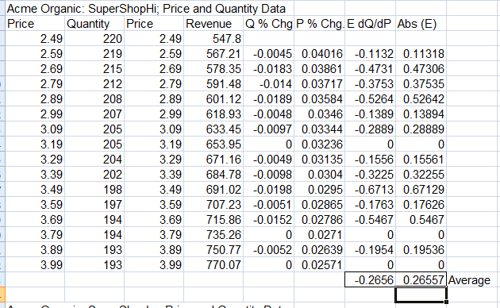

7. Repeat the process just completed for SuperShopHi, this time for SuperShopLo, and insert the screenshot of the completed result below.

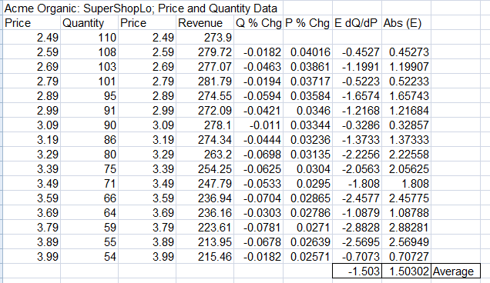

8. Interpret the results for SuperShopHi, by recalling that Elasticity holds the following meaning:

Elastic Demand: E > 1.0: Buyers maintain high price sensitivity, so increases in price will discourage buyers, causing revenue tends to decrease.

Inelastic Demand E < 1.0: Buyers maintain low price sensitivity, so increases in price will not cause major changes in behavior, so revenue tends to increase.

In the space below, state the average value for Elasticity that you calculated for SuoerShopHi, identify if that value is associated with elastic or inelastic demand, and predict if revenue will increase or decrease as price increases.

Elasticity: Average Value: 0.26
Elasticity less than 1.0, therefore inelastic demand
We therefore expect revenue to increase with increasing prices

9. Calculate the revenue for each Price-Quantity data point for SuperShopHi.
Note if revenue tends to increase or decrease as price increases.
Take a screenshot and place it below.

Elasticity: < 1.0; Inelastic, so we expect revenue to rise; Spreadsheet indeed shows revenue increasing.

10. Calculate the revenue for each Price-Quantity data point for SuperShopLo.
Note if revenue tends to increase or decrease as price increases.
Take a screenshot and place it below.

Elasticity: > 1.0; Elastic, so we expect revenue to decrease; Spreadsheet confirms decrease.

11. Prepare a table with the following columns: Price, Elasticity for SuperShopHi, and Elasticity for SuperShopLo. Plot out the elasticity values for SuperShopHi and SuperShopLo against price. Take a screenshot and place it below

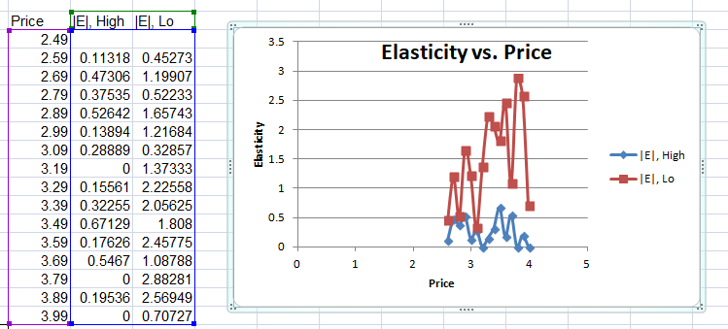

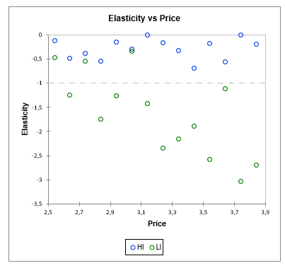
https://help.xlstat.com/customer/en/portal/articles/2967724-price-elasticity-of-demand-ped-tutorial-in-excel-?b_id=9283

12. Interpret the results by indicating the range of values for elasticity for SuperShopHi and that for SuperShopLo.

Range, SuperShopHi: 0.00 – 0.67; Narrow range
Elasticity does not appear to vary substantially with price.

Range, SuperShopLo: 0.33 – 2.88; Wide range

(Consider inserting box plot here)

13. Record your observations here

High income earners are more price insensitive. Low income earners are more price sensitive.

